过滤器Filter

概述
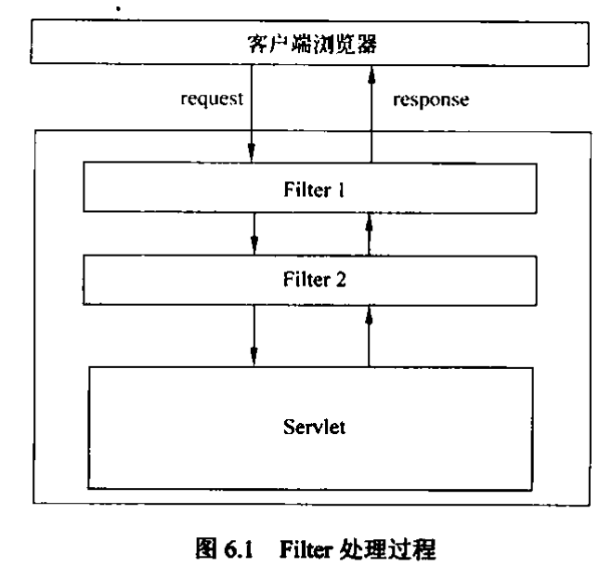

public class myfilter implements Filter {

public void destroy() {

}

public void doFilter(ServletRequest request, ServletResponse response, FilterChain chain) throws IOException, ServletException {
chain.doFilter(request, response);
}

public void init(FilterConfig fConfig) throws ServletException {

}

}

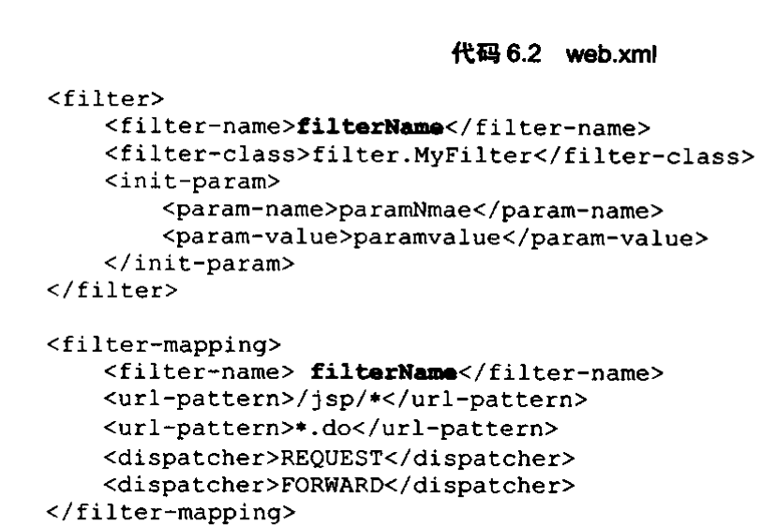

dispather取值区别：
- REQUEST:直接请求时有效
- FROWARD：转发请求时有效
- INCLUDE:JSP中通过<jsp:include/>请求时有效。
- ERROR：指定为错误页面时有效

